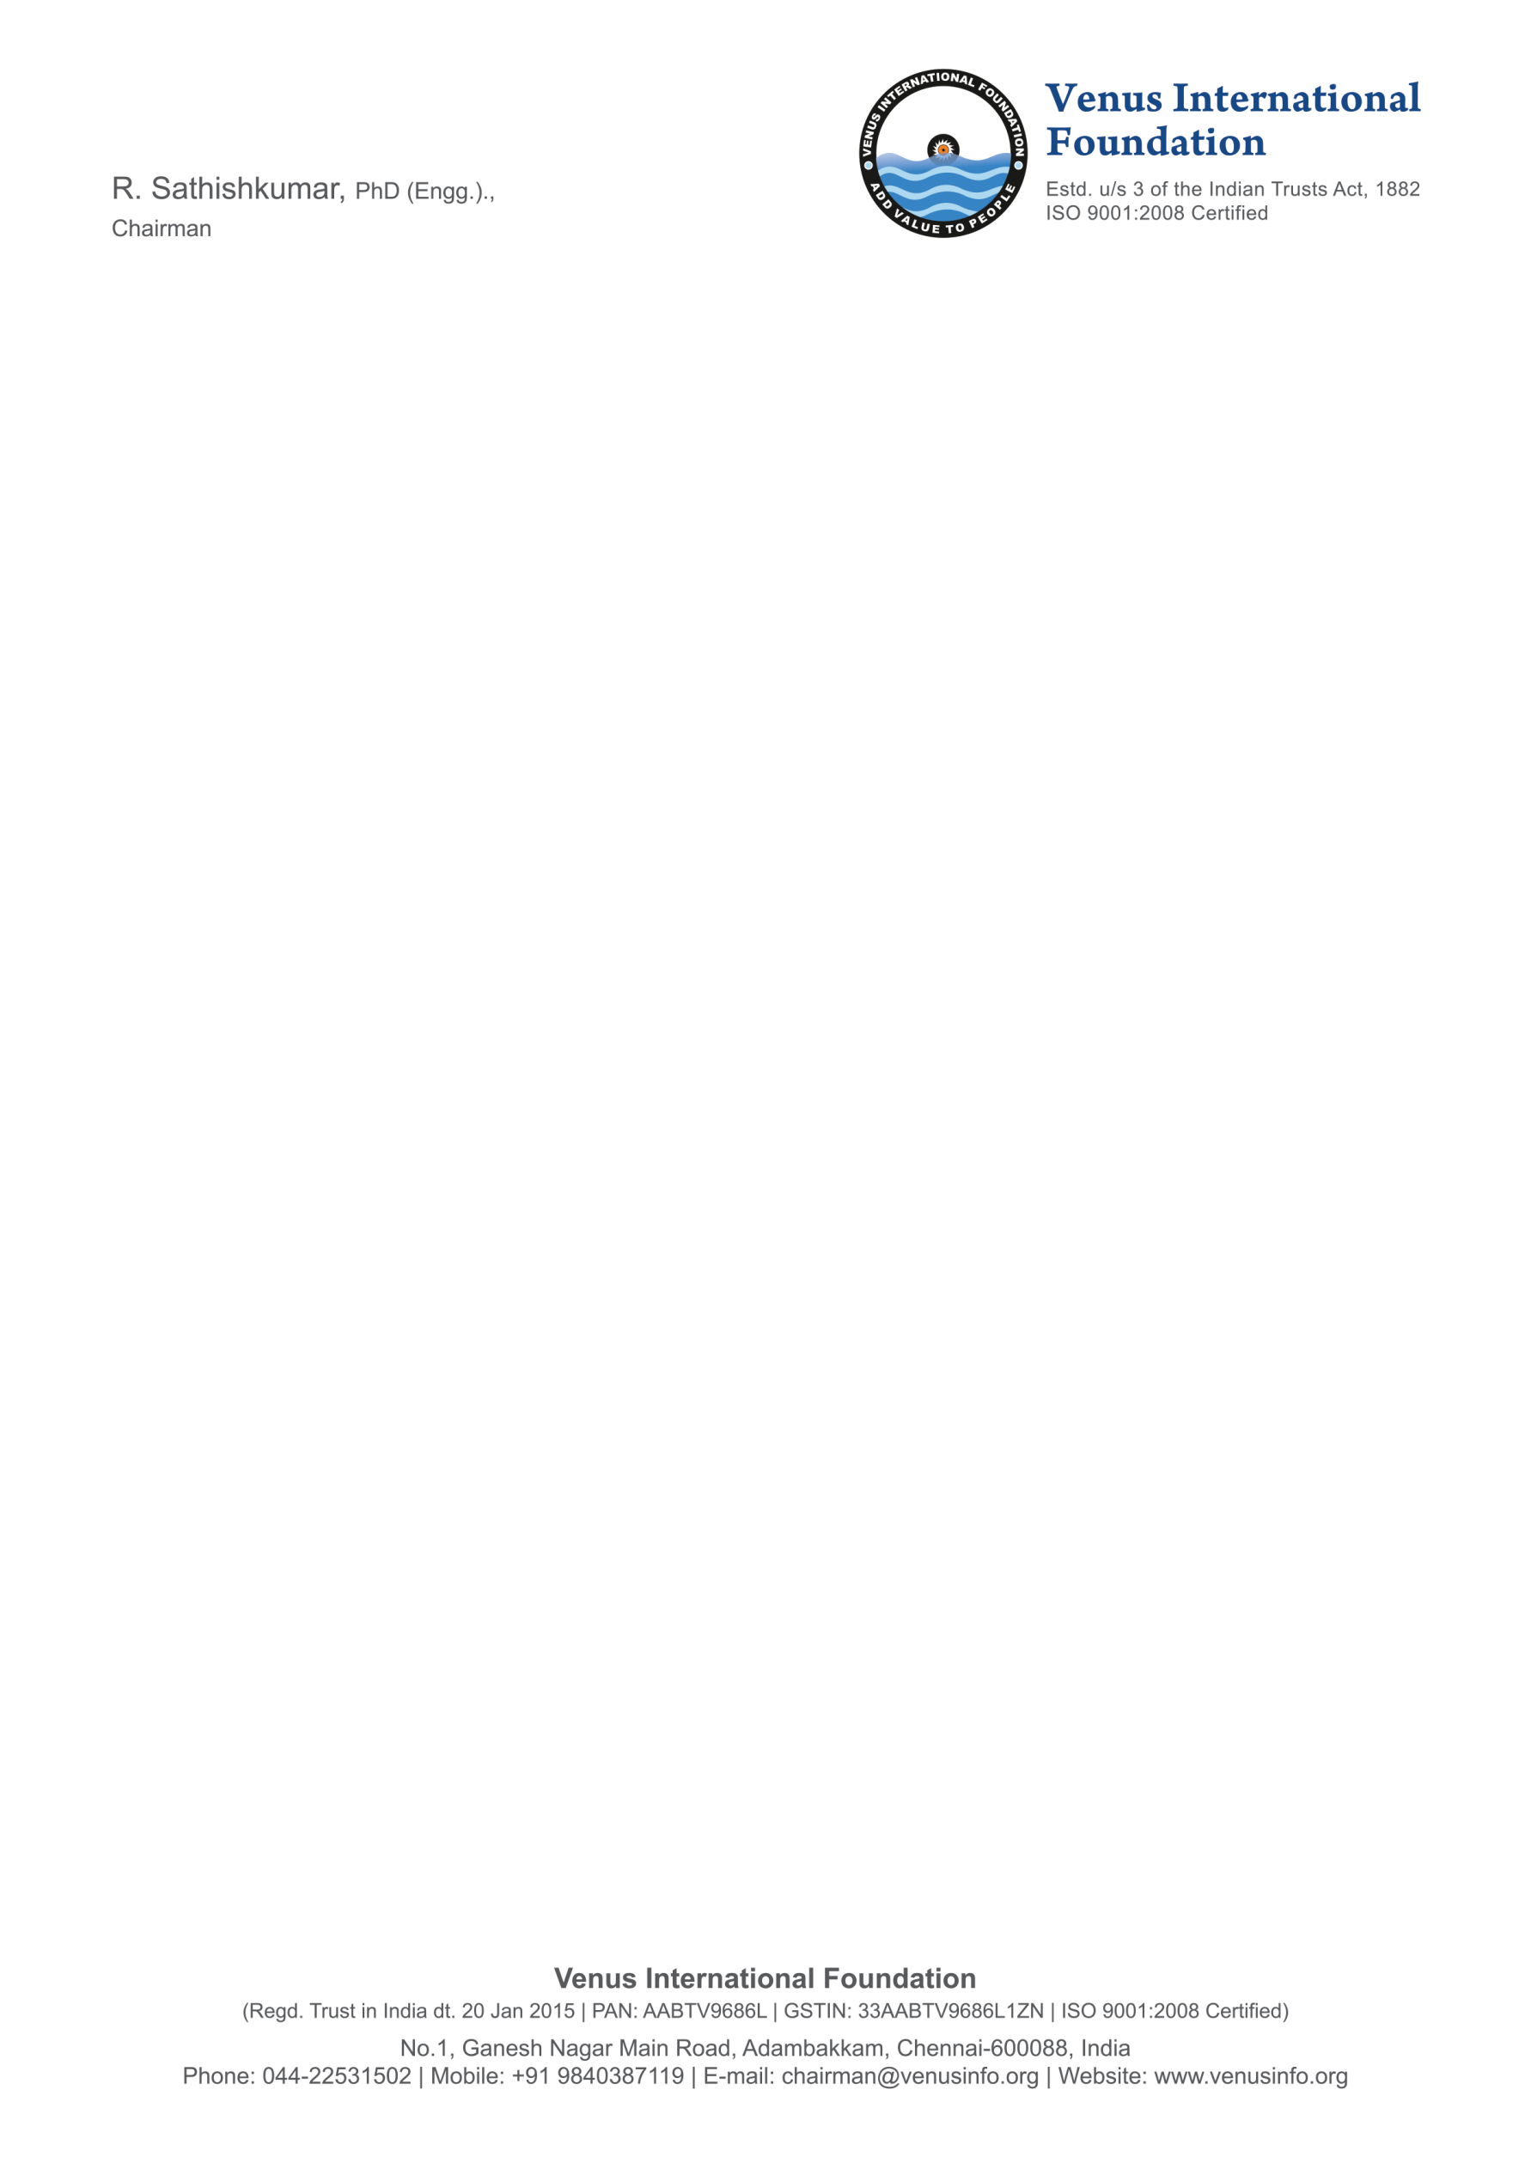 | A Non-Profit Organization  GSTIN: 33AABTV9686L1ZN  E–mail: contact@venusinfo.org  Phone: 044 – 22531502  Mobile: +91 9840556456
No.1, Ganesh Nagar Main Road, Adambakkam, Chennai – 600088, Tamilnadu, India

Official Nomination Form for 11th Venus International Women Awards – VIWA 2026
7 March 2026 at Green Park, Chennai, India | https://venusinfo.org/women/2026/awm.html
Section – I: Discipline (Refer clause 3 and 5 of policy document)
1.1 | Discipline
1.2 | Major area of Study/Research
1.3 | Award Category
Section – II: Personal Information
2.1 | Name of the Applicant | (Affix Recent  Passport Size  Photo)
2.2 | Date of Birth and Age
2.3 | Place and Country of Birth
2.4 | Nationality and Citizenship
2.5 | Marital Status
2.6 | Primary Email Address
2.7 | Secondary Email Address
2.8 | Mobile Number
2.9 | Education Qualification (Completed)
2.10 | Years of Experience
Section – III: Current Employment
3.1 | Name of the Institution
3.2 | Postal Address of the Institution
3.3 | Website of the Institution
3.4 | Date of Joining in the Institution
3.5 | Department / Division
3.6 | Present Designation
3.7 | Nature of Appointment (Permanent / Contract )

Section – IV: List your current research and development activities (100 – 150 words)

Declaration
I hereby declare that I have carefully read the CLAUSE 8 (Selection Process) of the VIWA 2026 policy document and agreed to the same. I confirm that to the best of my knowledge, the information given in this nomination form is correct and complete. At any time I am found to have concealed/distorted any material, information, my nomination shall be liable to be summarily terminated without notice/compensation. I agree to VIF to process the data submitted in this nomination form, or any other data that the foundation may obtain from me for any purposes connected with VIWA or AWM 2026 or for any other legitimate reason.

Date: Place: Scanned Signature of Applicant

Annexure – I
- A. Submission (Clause 10 of the Policy Document)
List of documents to be submitted
- The filled nomination form in pdf/.doc/.docx format
- Duly completed curriculum vitae (of any format/pages)
- Recent photograph
- Copy of degree certificate (PhD or Equivalent)
- Copy of workplace ID

Nominee has to submit the filled form and other necessary documents electronically to:
viwa2026@venusinfo.org (AND) directorvifindia@gmail.com

Note: The VIWA 2026 no longer requires a hardcopy of the Nomination Form.

- B. The VIWA 2026 Selection Process (Clause 8 of the Policy Document)
This section describes VIWA 2026 Selection Process

8.1 | Screening process (preliminary assessment) of nomination
8.2 | Acknowledgement intimation to the nominee
8.3 | VIWA team may ask proof for credits mentioned in the cv (optional)
8.4 | Cross verifying the documents and forwarding it to the committee
8.5 | Selected nominees will be communicated with an official email
8.6 | AWM 2026 Registration (Refer Annexure – B of the Policy Document)
8.7 | Release of the winners list in an official webpage
8.8 | An official email will be communicated to the award winner
8.9 | Award presentation ceremony
8.10 | Summary of AWM 2026 will be released in an official webpage
- C. The Secretariat
The General Chair – 11th Annual Women's Meet (AWM 2026),
Center for Women Development,
Venus International Foundation,
No.1, Ganesh Nagar Main Road, Adambakkam, Chennai – 600088,
Tamilnadu, India.
Ph: 044 – 22531502

- D. The Committee
Dr. R. Sathishkumar: General Chair (chairman@venusinfo.org)
Mrs. M. S. Sudha: Program Chair (+91 9840556456 | director@venusinfo.org)
Mrs. A. Sara: Program Co-Chair (awm2026@venusinfo.org)
Dr. T. R. Ganeshbabu: Publications Chair (contact@venusinfo.org)
Mrs. K. Nanthini: Publications Co-Chair (contact@venusinfo.org)

